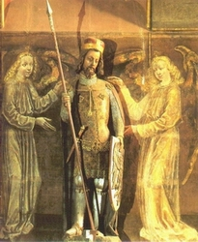
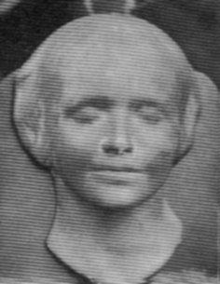
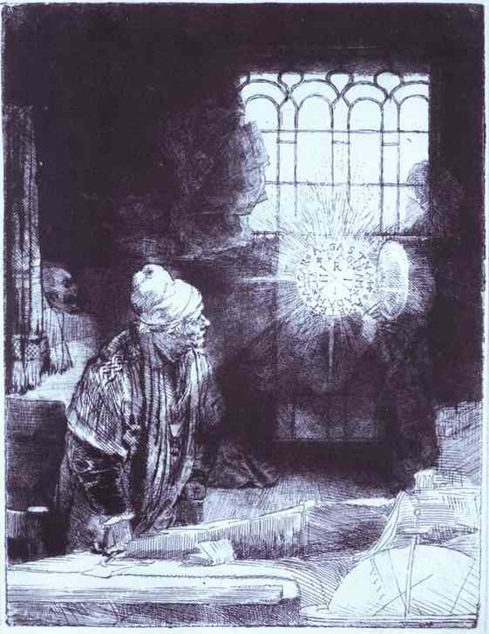

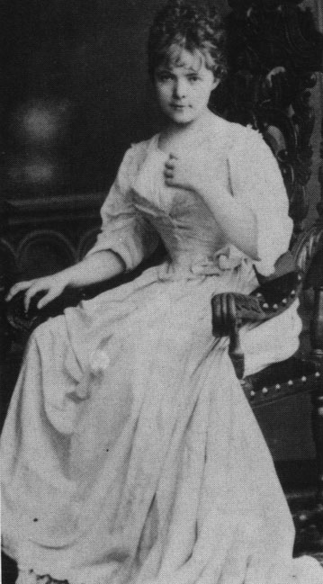
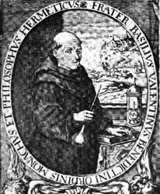
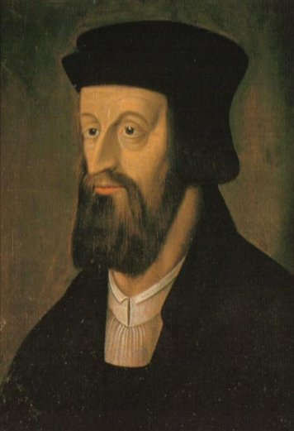
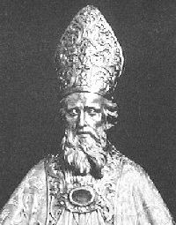
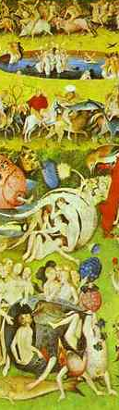
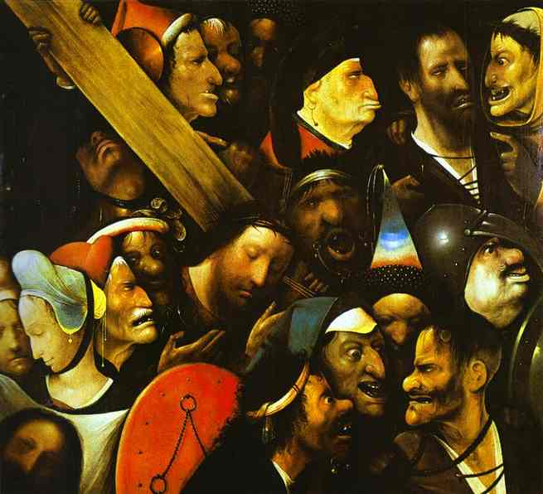
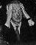
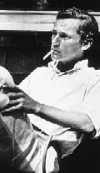
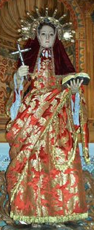
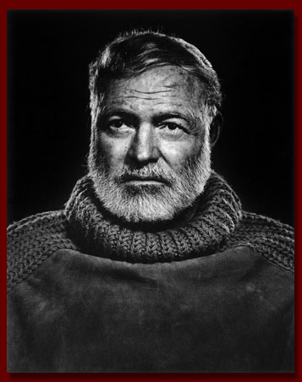
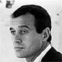
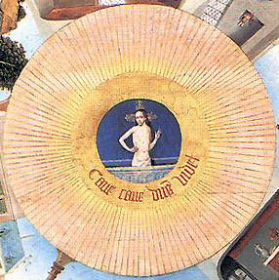
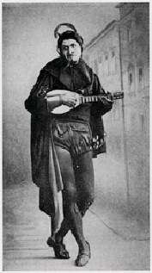
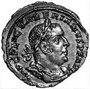
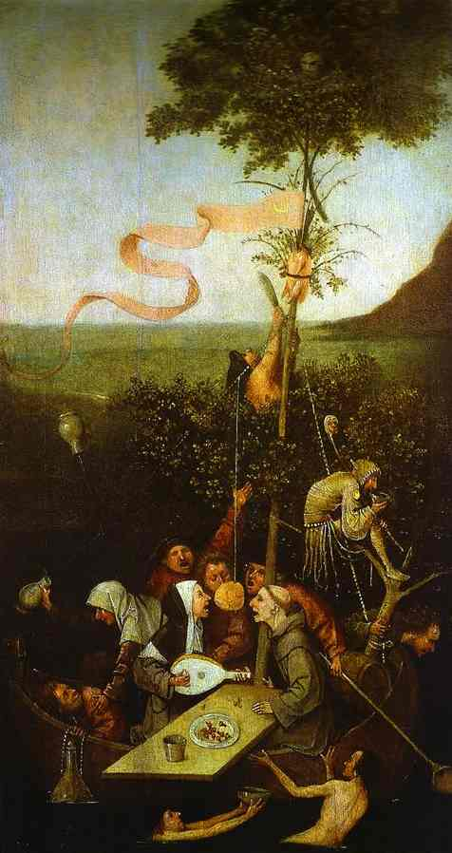
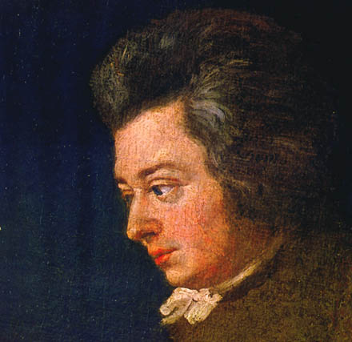
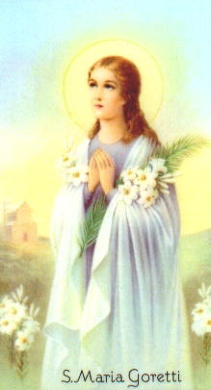
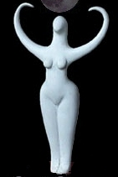
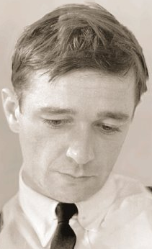
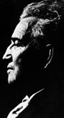
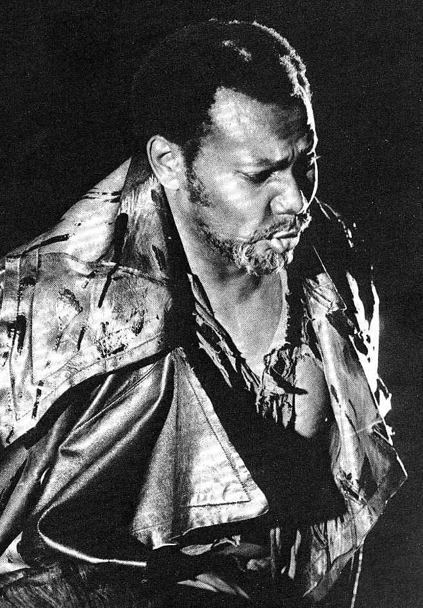
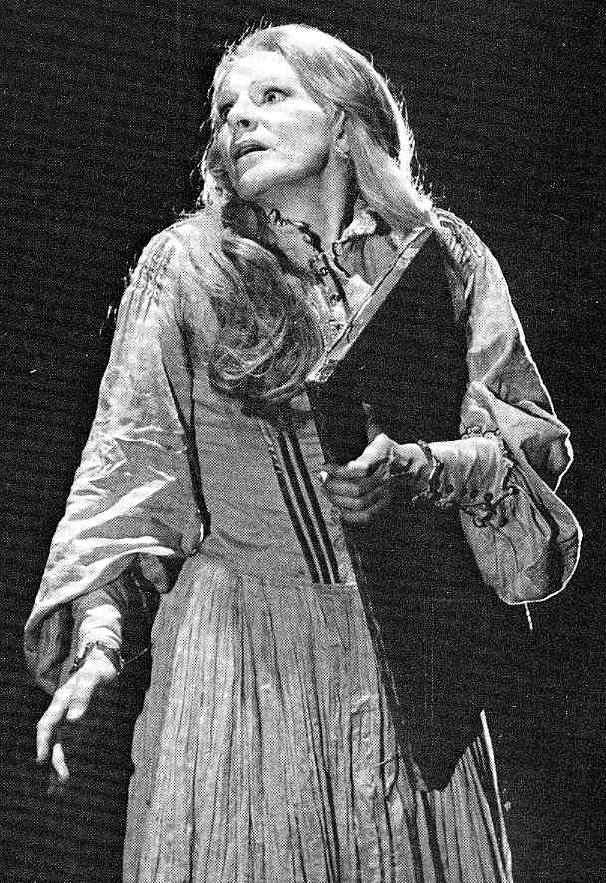
A Census of The Recognitions
Originally compiled by Anja Zeidler,
with additions from the annotations group
and readers everywhere: please send suggestions.
Numbers without brackets indicate that the character
appears in person.
Numbers in [ ] indicate that the character is only spoken of.
Numbers in ( ) indicate that the person is present but does not
(or cannot) talk.

Main Characters in The Recognitions
Quoting from Steven Moore's William Gaddis, Boston: Twayne, 1989.

Camilla
"For Wyatt [she is] the idealized figure Graves calls the White Goddess – at once girl, mother, and hag, and patroness of the white magic of art." (27)

Esme
"One of the strangest yet memorable heroines in contemporary literature, Esme betrays the absurdities of the role of romantic redemptress forced upon so many female characters by males who prefer virgins and whores to any more complex woman in between." (49)

Esther
"Esther is rational, big-boned, ambitious, and writes prose." (46)

Agnes Deigh
"Agnes and her flock skip over friendship and its perils and simply exchange the 'flowers' of friendship – […] empty civilities that counterfeit sincere friendship." (62)

Wyatt
"Wyatt – like every true mystic, alchemist, and magician before him – searches for a window on that transcendent state where suddenly "Everything [is] freed into one recognition" (R, 92)." (16)

Reverend Gwyon
"Reverend Gwyon abandons his son first for the Son, then for the Sun." (57)

Otto
"a comic double, a funhouse mirror reflection of the 'refugee artist,' […] a ludicrous counterpart to Wyatt." (41).

Recktall Brown
"Gaddis arrays Brown in all the trappings of the twentieth-century devil, a Mammon of the modern world." (49)

Basil Valentine
"Graced with taste, intelligence, and 'the best education money can buy' (R, 364), Valentine uses these gifts to place as much distance as possible between himself and others." (52)

Anselm
"Anselm is an enemy not of the religious but of the religiose. [He] veers violently between fierce blasphemy and a grudging respect for Christ's teachings." (55)

Stanley
"Reminiscent of Dostoyevski's Prince Myshkin or Alyosha Karamazov, Stanley is the holy fool of The Recognitions, moving through its sordid scenes with unassailable purity and goodwill." (53)

Frank Sinisterra
"A comic voice in the novel's aesthetic debate, Sinisterra exemplifies the danger of overreliance on heartless virtuosity." (58)

Mr. Pivner
"At the quiet center of the novel, Mr. Pivner is Gaddis's Willy Loman, and his failure is a similar tragedy for the common man." (60)

Character | Description and Appearance | First mention

A

Accordion player | Man from the Secret Service, playing in front of Mr. Pivner’s apartment house (741, 743-744) | (741)
Adeline | A nurse Herschel knew and bit (171) same as the woman Fuller knows, who has a daughter named Elsie? (343-344) | (171)
Alabama man | Alabama Rammer-Jammer man, in advertisement, the third man with Ellery and Morgie, a real “character” (733-738, 751-752) | (733)
Anatole | Bartender at hotel, where Otto doesn’t meet his father (509-510, 513) | (509)
Anselm  Saint Anselm of Canterbury | Poet, changed his given name Arthur into Anselm after Saint Anselm of Canterbury, looking after Bildow’s daughter, “that awfull boy” (177) badly shaved boy (182), thin face, bad case of acne, “excellent poet” (309) “thin broken face” (632), castrating himself (645), (766), publicity agent for a monastery (936) (103-104, 177, 182-185, 194-197, 199, 200, 206 (newly shaven face), 208, 210, (217), 309, 310, 323, 328, 356, 452-458, 476-478, 523-537, 584, 600, 604, 610, 616, 617-618, 620, 622-623, 624-625-625, 628-637, 642-643, 645, [746], [747], [766], [845], [917], [[930]], [932], [936], 936.) | (103)
Anselm’s mother | “sweet little Boston woman,” “awfully interested in dogs, awfully anti-vivisection” (309), “she’s a nut” ([309], [532], [642-643], [645]) | (309)
archeologist | Friend of Rev. Gwyon, who had given a pair of ear-rings (heavy Byzantine hoops of gold) to Camilla and whom Gwyon had never seen again since. (14) | (14)
Miss Ardythe | The organist who “dropped stone dead at the keyboard with her sharp chin on a high D” (14) during Gwyon and Camilla’s wedding. | (14)
Argentinean | Argentine trade commissioner at the wrong party, at Esther’s party, shark-skinned, greasy-looking guy with shiny hair, "short shiny figure" (615) (581, 596, 597, 604, 609, 615, 631, [639], [640], [641], 659, 673, 680) | (581)
Aunt May | Sister of the older Rev. Gwyon (Rev. Gwyon’s nameless father), “barren steadfast woman” (3), Calvinist, Wyatt’s Christian mentor (19), flesh-and-bloodless woman (20), dies when sixty-three (40) (3, 4, 14 18-21, 24-40, [41] 61, 88, [401], [434], [706]) | (3)

B

Baby | At Esther’s party, child of the woman with bandaged wrists, a year old, taken away by Maude (578, 583, 596, 604, 631, 638, 756 | (578)
Barney | Barkeeper in a Lexington Avenue bar (100-101, 103, 645-646) | (100)
Beard, the | Man with black beard, friend of Esme (176?, 308, 309) | (308)
Benny | Ben somebody (Esther), works in Wyatt‘s office, later works in advertising with Ellery, anxious man, commits suicide (738) (96, 147, 149, 572-573, 578, 579, 581, 582-583, 593, 594-596, 599, 600-, 604, 605-607, 609-610, 627, 638, 640, [736], [738]) | (96)
Bernie | Fat man in yellow and brown necktie, at the zoo, reappears in Spain, husband of woman with ring, expensive camera (542, 879-887) | (542)
B.F. | Working in advertising with Ellery (738) | (738)
Bildow, Don | Editor of little magazine (The Magazine) (94, 106, 179, 183, 196, 309, 526, 569, 572, 574, 575-577, 580, 601, 604, 608, 612, 613, 617, 618, 622, 623, 628, 629, 636-638, [640], 745-746, [747], 765, 836-837, 910, 917-918, 924-925, [940], 953-954) | (94)
Bildow, Mrs | Don Bildow‘s wife (103, 179, 309, 765, [924]) | (103)
Bildow, daughter | six years old, Anselm is her baby sitter, left by Anselm at a show, pregnant by Anselm (745) ([103-104], [309], [452-458], [618], [636 and earlier], [745], [837], [924]) | (103)
Boston girl | Tall light-haired girl, “pleasing Boston-bred voice” (477), at Esther’s party, laughs a lot, “Somerset Maugham my ahss” (262), “Freud my ahss” (477) (262, 308-309, 310, 477, 581, 607, 631, 639) | (262)
Blond boy | At Viareggio’s, at Otto’s side (476) | (476)
blonde | See under Jean
Haggard boy | At Viareggio‘s, “haggard face” (536) (476-478, 529, 536) | (476)
Boy with red cap | At Viareggio‘s (309-310) | (309)
Little boy | At the zoo, infront of the polar bear cage (542) | (542)
boy | Boy in something like a Boy Scout uniform, in the lion house at the zoo, talking to the lion (550) | (550)
Conte di Brescia | Collector, who sold Bosch’s Seven Sins painting to Reverend Gwyon, “the old Italian grandee” (25, 59, 246, 918, 956) associated with Basil Valentine by Stanley [who remembers a painting of him ? 918]; namesake of Adamo da Brescia mentioned on 5.30 as a pioneer in counterfeiting “even now [suffering] in Malebolge” (5.28), part of Dante’s inferno that is (cp. note 5.28,  http://www.williamgaddis.org/recognitions/I1anno1.shtml). Adamo da Brescia was burnt alive in 1281, because he had forged florins for the count Guidi da Romena. | (59)
Seraphina di Brescia | Tall dark woman, Big Anna looks for her at costume party, the timid Italian boy is her cousin (310), called Jimmy (315) (310, 314, 315), see note 59.36 (http://www.williamgaddis.org/recognitions/I1anno4.shtml) | (310)
British, R.A. | Tall white-haired man in gray on Brown’s party, identified with a London gallery of some prominence, R.A. (Royal Academician), called “the member of the Royal Academy (677), (657-661, 665, 666, 670-671-672, 674-678, 679-680, 681-682, 844) | (657)
Bronzino | At costume party (311), see SM 311.22 (http://www.williamgaddis.org/recognitions/21anno2.shtml) | (311)
Brown, Buster | A writer, 23 or 28 years old (194, 295, 581, 582, 925) (see SM 194.38: Obnoxious little boy in R.F. Outcault‘s comic strip), | (194)
Brown, Recktall  Mephistopheles (with whom Recktal Brown is associated, cp. R, 135) | A businessman (141), publisher, collector, dealer, terribly fat man (210), there is a likeness between his portrait and the head of a wart hog (227), “shuffling sound of metal on metal” (677), "the devil wearing false calves (676), “broken weight” (death, 677), Chancellor Rolin in van Eyk's Virgin and Child and Donor (689) (140-146, 209, 210, 223, 225-242, 244-260, 328, 343, 345, 346, 349-356, 357-365, 375, 380, 381, [543], [547], [551], [553], [654], 655-656, [661], 662-665, 666, (667), 668-670-671, (672), [673], [674], (676), (677-678), (681), [687], (689)). {Picture: | (140)
Byron, Sonny | Young black man at Max‘s party, in company with Buster Brown (194, 581, 594, 604, 627, 641, 925, [941]) | (194)

C

Cab driver | Driving Valentine and Wyatt (263) | (263)
Captain | The captain of the Purdue Victory (4, 5) | (4)
Child eating rose | 18 month old, hatless, wet-nosed, seen by Wyatt and Valentine at the zoo in front of the seal pool (544, 548) | (544)
Christiane | Blond model sitting for Wyatt in Paris (67, 69) | (67)
Cleaning women | (162-163) | (162)
Crémer | art critic, knows Recktall Brown from the army, at his party (231), “offensive little Frenchman,” he resembles Valentine in a dismally obvious badly dressed way, critic in La Macule (664) (70-72, 653, 655-656, 659-660-661, 663, 664-666, 670-671, 678, 679, 680-681, (687), [940] | (70)
Critic  Wolfgang Amadeus Mozart | Tall man in green wool shirt, first appears on Max’s party, “some half-ass critic” Anselm says, gaunt man, tall, “used to do book on Old Masses (570), open-collar shirt, looks like "A rather unfortunate print of Mozart (it was in profile, the frontispiece in a bound score of the Jupiter Symphony printed in Vienna)" (574), always looks offended, his wife presumably shot herself (576, “Deedee Jaqueson [604?]) (575), has myopia, Agnes claims to have been nursing him for a year, brown eyes, plastic surgeonry on his nose, is said to have a nice name, Stanley claims he looks like an Inquisitor (600) (ca. 200, 453, 476, 569, 574-575, 576-577, [580], 581, [584?], 595, 596, 599, [600], 601-608, 609, 622, 626, 627, 630, 635, 636, 641, 642, 935-937) | Ca. 200
Cross-eyed girl  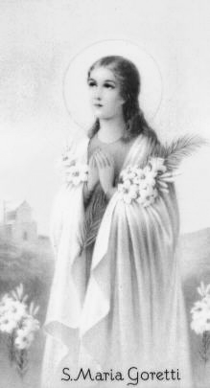  Saint Maria Goretti | Little cross-eyed girl in long white stockings (7), raped and killed when eleven years old (16, see also porter), "our Little Girl" (17), next to Camilla on the church yard of San Zwingli, Senor Hermoso believes she would make a perfect patron saint for the village (17), "the dark, withered, and childish-figured contents" (792) ([7], [12], [16], [17], [291-292], [429], [791], (792)). Also cp. note 16.12 here:  http://www.williamgaddis.org/recognitions/I1anno1.shtml  based on the life of Saint Maria Goretti. | (7)
Mr. Crotcher | someone Buster Brown thinks Esther must meet, a writer, having translated his own book on ant life into nineteen languages already, later on a quizz show (582-583, 596, 604, 608, 613, 624, 640, 641, 743)

D

Dalner | Owner of Dalner Gallery (231) | (231)
Darling, Morgie | Advertisement man, from Yale (Skull and Bones) (734-738, 750, 751-753) | (734)
daughter | Daughter of Pastora and Wyatt ([897-898]) | (897)
Deigh, Agnes | Literary agent, back from Puerto Rico, “old bag with the Mickey Mouse watch,” mother to every fairy in the city (580), attempts suicide (100, 176, 181, 185, 187, 188, 191-193, 195, 196, 197, 199, 293-298, 307, [311, 312, 313], 314, 315, 316, 323, 325-328, 329, 554-556, 571, 577, , 580, 581-582, 597-600, 604, 608, 610-611, 615, 617-618, 628-629, 631, 632, 636-638, 643-644, [645], [657], 695, 739, [745], 754, 755, 763-764, [903], [915], [928]) see also note 176.43: http://williamgaddis.inwriting.org/recognitions/I5anno1.shtml | (100)
Deigh, Harry | Agnes‘s husband, Mr Six-Sixty Six, dies falling off a bar stool in Hollywood (177, 178, 293, 294, 295, [763]) | (177)
Mrs. Deigh | Agnes’ mother, she has the same name as her daughter, stout woman, lives in Rome on the via Flaminia ([315], [695], [754], 901-904, 905-906, 907-909, 914-916, 925-928, [950]) | (315)
Mr. Deigh | Agnes‘s brother, a writer (177), missed in WWII, killed (177, 294, 297) | (177)
Dick | Young minister replacing Reverend Gwyon (707-711, 714-720) | (707)
Dickens, Charles | At Max‘s party, called Charley, guilt feelings from dropping an atomic bomb, silver plate in his head, looking for razor blades at Esther’s party, moving like a shadow there (181, 195, 307, [455], [478], [531-532], 572, 578, 629, 630, 937, [940]) | (181)
Mrs. Dickens | Charles’s mother, “that old bag”, a Christian Scientist ([455], [478], [531-32]) | (455)
Mrs. Dorman | „dumpy deep-chested boarding-house keeper, singing in the church of Rev. Gwyon (21) | (21)
Drunkard | Talking to John in the bar, talking to Valentine at the corner of Gansevoort Street (268, 269, [284?], 331-332, 342, 388) | (268)
Duchess of Ohio | At Esther’s party (576, 583, 584, 604, 626, 641) | (576)

E

editor | Editing Esther’s book, married to tall woman ([553, 554], [568], 569, 570, [597], [604], 607, [613], grey flanell sleeve?, 618-619, [628], 655, [657], 765, 805, 815, 825, 864-865, 879-881, 886) | (568)
Edna Mims | Girl friend of Otto with a magazine, Otto used to go out with her in College (Radcliffe), Max‘s girl friend, working for Brown, “dumb Radcliffe girl,” blond (577), also having worked for the nameless critic (577) (207, 308, 317, 351, 577, 633) | (207)
Ellery | Advertising man, Esther‘s lover (151, 366-372, 568, 571, 572-573, [578], [580], 582, 594-595, 603, 604, 605-607, 609, 627, 639, 640, 733-738, 750-753) | (151)
Elsie | Daughter of Adeline, Fuller‘s acquaintance, died at age of three (343) | (343)
Ernie | Big unshaven man, looks like Ernest Hemingway (306, 307, 308, 309, 310, 525, 632, 748)  {Photograph of Ernest Hemingway by Yousuf Karsh, 1957} | (306)
Esme  Sheri Martinelli, a model for Esme  Noyeé de la Seine (cp. R, 177) | Skinny little girl (173), girl on the couch (177), noyeé de la Seine (177), Praxiteles statue of Phryne (185), “friggin madonna” (189), “die Frau nach der man sich sehnt, das Ewig Weibliche” (189), she writes poems (196), manic depressive schizoid tendencies (197), has a four year old child (197), she looks like she thinks she is a painting (198 also 306), whore (199), "your girl" (Anselm to Stanley, 200), Baganda woman (209), a kid I got for him (241), she‘s a niece little piece (259), Max claims she is pregnant (459), “the serenity of a woman in a painting” (306), tries to kill herself with gas (478), Solveig, Senta (550), that skinny girl (746), priestess of Delphos (754), going to become a nun (912), a regular eye-tye madonna (913) (173, 177, 183, 185, 189, 193, 194, 196-201, 202-112, 216-221, 241, 259, 269-277, 298-302, 303, 304-307, 308, 309, 310, 311, [314, 315], 321, 323, 328, 354, 361, 446-452, [455], [459], 467-473, [478], 478-485, [526], [549?], [550-551], [624?], [699], [746], 754-755, 765-768, 824, 826, [827-828], 830-835, 838-844, 845, [849], [851-853], 909, [911-13], 921-924, [927], [952]) | (173)
Esther | Wyatt’s wife, Otto‘s lover, Ellery’s lover (78-100, 104-136, 172, 213, 219, [310], 328, 337, 364, 366-372, 374, [507], [508], [558], 568-569, 570, 571-572, 573-574, [576], 577-580, [581], 582-596, 603, 606, 607, 608, 609, 611-612, 613, 616, 618-622, [623], 627, 628, 637, 639-642, [750]) | (78)
Eulalio, Fr. | 1. Monk at the Real Monasterio de Nuestra Senora de la Otra Vez in former times, “a thriving lunatic of eighty-six (10), Fr. Eulalio Epiclantos, ‘weeping so much’ (10, 11)  2. Monk at the Real Monasterio de Nuestra Senora de la Otra Vez when Wyatt Gwyon stays there, in his twenties (859-860, 864, [868], 879-880, 884-886) | (10)  (859)

F

Frau Fahrtmesser | German woman who wants her daughter to be canonized by Dom Sucio ([914]) (FahrtENmesser is the German for ‘sheath knife’) | (914)
Mr Farisy | Patient at the asylum Reverend Gwyon also stays (712-714) | (712)
Feasley, Ed | Studied with Otto at Harvard, Max in Otto‘s play, a drunken boy in Mr Pivner‘s words, recognizable by his ‘Chr-ahst’ (287) (121-22, 189, 190, 194, 195, 197, 287, 308-312, [314], 315, 316-318, 324-325, 571, 581, 583-584, 597, 604, 609, 613, 614-615, 631?, 637, 639, 640, 641, 745-750, [[930]], 932-933) | (121)
Mr Feasley | Ed Feasley’s father, „my old man,“ owner of battleships, in the Times ([326], [596], [597] [615], [747], 932 | (326)
Mrs Feasley | Ed Feasley’s mother ([615]) | (615)
Feddle | “Poet” to be published soon, always inscribing books (190, 195, 308, 310, 524, 533, 537, 574, 581, 594, 597, 604, 605, 606, 620, 622, 627, 638, 640, 935-936, 938) | (190)
Feddle, Mrs | Mr Feddle‘s wife (191, [533]) | (191)
Dr. Fell | Doctor mistreating Wyatt, also treating Otto later (42, 730-732, 930-932, 950)
Flower-Cart Man | Selling Lilies to Wyatt (266) | (266)
Frank | Friend of Rudy (925, 941, 944-945) | (925)
Franks, Jesse | Man Otto knows in Central America, tattooed (154-158, [189], 731) | (154)
Frenchman | At Brown’s party, “offensive little Frenchman” (659) from Lyon (672) (657, 659, 672, 673, [675]) | (657)
Friend of Benny | He went to school with Benny, has written a history of the player piano (579) (578-580) | (578)
Fuller | Recktall Brown‘s servant from the Barbados, a posession of some sorts (235) (225), a set of gold teeth (222), scared of the dark (226), “that black Ganymede” (657), (222-226, 235, 237, 258, 259, 260, 303, 328, 343-349, 357, 358, 361, 362, 444-445, 654-655, 656-657, 668, [669]; 670, 678-679, 682-683, 692-694, 726, 949-950) | (222)

G

George | Acquaintance of Max, reading Otto‘s play, round-headed, salesman (307, 524-525) | (307)
Giono | Italian boy the Swede wants to adopt for his own pleasure (314) | (314)
Girl, bandaged | Both wrists bandaged, talking to tall woman, her husband a writer, she Catholic (568, 578, 581, 583, 595, 614, 617) | (568)
Girl, dark | Dark girl at Bella Vista hotel serving lunch to Otto (729) | (729)
Girl, flat | At Max's party, "the profane girl" (193) (192, 193) | (192)
Girl, green tongue | At Esther’s party, playing with baby (584, 595, 624, 629) | (584)
Girl, little colored | At costume party, in purple dress, she is a man (315, 940?) | (315)
Girl, little | Seven year old girl from the apartment below Esther’s, fetching sleeping pills for her mother, who later dies (750) (572, 582-583, 593, 597, 614, 629, 642, 750) | (572)
Little girl at the zoo | Girl in front of polar bear cage, complaining (542) | (542)
Girl, pale | Seen by Stanley in Rome reading Forster (906, 910) | (906)
Girl, small | Smallest of three girls at the zoo, gets and loses a balloon (546, 552) | (546)
Gordon | Character in Otto‘s novel, „resembled Otto at his better moments“ (121), more and more after Wyatt (156), „hero of the play“ (121, 122, 123, 130, 151, 156, 351, 530, 732) | (121)
Guest of honor | Writer at Esther’s party, Ludy (588)? ([574], [601], 612, 616, 620) | (574)
Gwyon boy | Had made an end to his life when nine years old by tying “a string round his neck with a brick to the other end, and jumped from a footbridge into two feet of water,” drowning ([13]) | (13)
Gwyon, Camilla  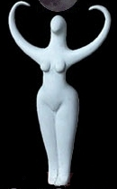  The White Goddess  "For Wyatt Camilla […] is the idealized figure Graves calls the White Goddess," (St. Moore, 1989, 27) | Rev. Gwyon‘s wife, marriage (14), Wyatt‘s mother, dying of appendicitis on voyage to Spain, seems to have been quite beautiful , Wyatt‘s portrait of her stays unfinished, “the still woman” (4), “one more piece of luggage […] “Importación ilegal de carnes dañadas […] cadaver […] cumbrous bundle” (6), “heretic guest” (7), “like that remontant goddess” (14), "his virgin mother" (19), Wyatt sees her ghost, "dressed in white sheets looking for something" (20), photograph of her on the living-room mantel (57), Rev. Gwyon gives Wyatt two of Camilla’s ear rings, “large studded Byzantine hoops of gold” (60), in the painting “ a woman looking just beyond you, her hands folded across in front of her shutting you out” (128), “the lady in the painting” (272), Esme sits for the painting, “Your blessed Queen of Heaven,” “sainted mother" (549) ((3), (4-5), (6-7), [8], (11), (12), [14-15], [17-18], [19], (20), [22], [23], [26], [27], [32], [39], [52], [57], [60], [61], [83], [84], [88], [128], [138], [272], [429], [434], [492], [549], [706], [780], [791], [793], [814])  Also cp. note 3.1. here: http://www.williamgaddis.org/recognitions/I1anno1.shtml | (3)
Gwyon, John H. | 18th century ancestor of the Gwyon family, “butchered by disaffectionate Indians” (22) | (22)
Rev. Gwyon | Rev. Gwyon‘s father, dies the year before his son‘s and Camilla‘s marriage, Aunt May’s brother, has his birthday in May (37) (3, 14, 37) | (3)
Gwyon, Reverend  Valerian, with whom Wyatt associates his father | Camilla‘s husband, Wyatt‘s father, 44 years old when Camilla dies (7), “there is some of Christ in him” (11), a big man, minister at the First Congregational Church, to Wyatt as a boy “somehow his father and the Lord were the same person” (20) Wyatt compares him to Valerian in a painting by Memling (421), death (717) (3-4, 6-62, 67, 90, 267, 268, 269, 394-400, 413-415, 418-421, 424-433, 436-437, 440-441, [701-702], 703-705, 711-714, 717, [892]). Also cp. note 3.9 here:  http://www.williamgaddis.org/recognitions/I1anno1.shtml | (3)
Gwyon, Wyatt  Jan Hus, like Wyatt the pale thin man  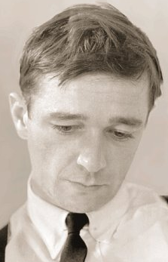  Walker Evans, whom Gaddis had in mind as a modell for Wyatt Gwyon. | Son of Camilla and Rev. Gwyon (14), four years old when father returns home (18), sand-colored hair, hazel eyes which burnt into green on angry occasions (18), “this fragment of hi[s father]” (29), meant to be called Stephen (27), goes to Munich (68) and Paris (67ff.), last appearance of his name (118), he (220, 221, 227, 235), a protégé with no animal self (229) in his thirties, a possession of some kind? (235), is he happy doing this work? (236), my boy (236), his face a shock (236), impassive figure (344), "you remind me of a boy […] Martin (383), some one [480], “You’re a romantic” (Valentine, 551), “funny sort of chap,” “madman” (660), “odd sort of fellow […] bit of a lunatic” (671), “diverting visitor” (677), named Stephan (Asche) by Sinisterra/Yák, “unsteady figure” (863) (785) (14, 18-21, 26-62, 67-72, 74, 77, 78-100, 104-119, 136-146, 164, 177, 220, 221, 227, 229, 235, 236-259, 260-264, 266-269, 270-275, 332-339, 344-349, 354, 357-365, 367-371, 374-385, 387-389, 390-400, 404-414, 420-421, 424-435, 438, [441], 443-445, [480], [482], 542-554, 585-593, [594, 595], [621], [652-3], [654], [660], 662-663, [671], 676-677, 680, 681-682, 683, 684-694, 699, [706-707], 776-818, [840], 863, 866-879, 887, 891, 892-900, [922]) | (14)

H

Hadrian | Mrs. Deigh’s aging bull terrier (906, 907, 928) | (906)
Haggard boy | At Viareggio‘s, “haggard face” (536) (476-478, 529, 536) | (476)
Hall, Albert | Friend(?) of tall Swede, Victoria and Albert Hall, wrote a play (192, 314, 522, 836-837, 925) | (192)
Hall, Victoria | On the boat with the tall Swede, together with Albert, wrote a play (192, 314, 522, 925) | (192)
Han  Han van Megeren | Boy Wyatt knew from Munich, killed in self defense by Wyatt in Africa ([93], [95], [877]). Name possibly refering to the Dutch forger Han van Megeren's first name [see Tom Sawyer's 1982 essay on R and van Megeren in bibliography:  http://www.williamgaddis.org/bibliography.shtml#sec-b (http://www.mystudios.com/gallery/han/exhibit.html) | (93)
Hannah | Village artist, plainly unattractive girl of the Village, amateur psychologist, "that nomadic laundress" (560), referred to in newspaper as Stalinist or Trotskyite (747) (179-187, 195, 196, 197, 201, 208, 216, 310, 323, 325, 341, [448], 476, [477], [478], 524-525, [527], 530-534, 560, 745-749, 932, 940-941, 944) | (179)
Heavy-necked person | Having lunch with Esme, having nude photos of Esme, “gentleman from the movies by Esme (448), pornographer, selling photos to Otto (446-447, 448, 538) | (446)
Hebble, Bertha | Cleaning woman at the zoo (540) | (540)
senor Hermoso | Language teacher in Spain, runs a drugstore in San Zwingli (17, 790), his face round, of limb flappy quality, exquisite mustache and penetrating eyes (17), “some spic,” his picture as rapist in newspaper (292), "has this real holy attitude about everything" (790), suing newspaper for four million lire for mistakingly printing his picture as rapist (846) (16-17, [739-740], [790-791], [798], [799], [846]) | (16)
Heracles | Tailless barbary ape from Gibraltar (18), destroys hawthorn tree (40), later killed by Gwyon (50) (18, 26, 31, 32, 39, 40, 50) | (18)
Herschel | Friend of the Munks, good looking man from Ohio, turns movie star (747), marries Adeline Thing (170-175, 176-181, 191, 195, 197, 198, 201, 208, 314, 316, 328, 557-558, 570, 610, 619, 626, 639, [747], 911) | (170)
Huki-Lau | Hawaiian poodle dog (Huki-Lau means ‘fish picnic’ in Hawaiian), wears a chastity belt against the naughty Spanish doggies (825, 846, 880, 921, 922) | (825)

I

Immaculate boy | Presumably a writer (295, 296) | (295)
Miss Inch | Nurse at asylum where Revernd Gwyon stays (712, 714) | (712)
Mister Inononu | Hungarian secret agent, calling Basil Valentine from Castel Gandolfo, later appearing under the name of Dr. Kuvetli, senor Kuvetli, sharp-bearded man, “oriental sort of chap” (658-659), “calls himself Kuvetli, an Egyptian” (662), is concerned with the mummy Ink-naton (662), speaker (665), identified by Valentine (666), sharply bearded, sharp-eyed man (672), (383, 385, 647-653, 658-659, 662, 665, 666-668, 672, 673?, 682?, [774], [821, 822], 918-921, 948-949) | (383)
Italian boy | From Sicily, Chinless, on Max‘s party, cousin of dark tall girl at Viareggio‘s (194, 310) | (194)

J

Janet | A girl with a tic, born a few minutes after her mother‘s death (24), her father a surgical belt salesman from New York (24), kitchen girl in the household of Rev. Gwyon (24, 25, 29, 30, 44-45, 47, 49, 59, 401-407, 412-413, 420-421, 425-426, 428, 433, 437-438, 440, 441, 442, 709. Also cp. note 24.25 here: http://www.williamgaddis.org/recognitions/I1anno2.shtml | (24)
Jacqueson, Deedee | Wife of critic in green wool shirt [576, 604, 609] | (576)
Jean | Blonde at the hotel bar where Otto wants to meet his father (506-507, 509-511, [515], 516, 521) | (506)
Mr. Jenner | Patient in Bellevue hospital (764) | (764)
Jerry | News-vendor near Mr. Pivner‘s apartment (284, 741) | (284)
John | Priest, studied with Wyatt for the priesthood (115, 266-269, 387-388) | (115)
Jones, R.L. | SUN STYLE FILMS, on the phone: “We have nothing to discuss.” (474) (214-216, 303, 474) | (214)

K

Herr Koppel | Wyatt‘s teacher in Munich, (70, 95) | (70)

L

Leak, James | At Esther’s party, has published a book (584) | (584)
Ludy | A distinguished novelist, staying at the Real Monasterio de Nuestra Senora de la Otra Vez, “a comfortable man of middle age,” the distinguished guest at Esther’s party with Glen Urquhart plaid suit (588)? (588, 857-864, 866-879, 879-883, 886, 887-900)

M

Man, with baby | At Esther’s party, the husband of the girl with bandaged wrists, a tight-rope walker (578, 583) | (578)
Burly man | Man in the Depot Tavern, commander of the local American Legion post (703, [707]) | (703)
Man, on bus | talking to Mr Pivner on the bus (503-505) | (503)
Man, checked suit | Man waiting for Frank Sinisterra to get money, the pusher (520, 521-522, 524, 539-540) | (520)
Man, fat | Husband of woman with ring, in yellow and brown necktie, at the zoo, at the monastry in Saint Zwingli, always carrying a camera (542, 879-887) | (542)
Man, green silk necktie | Publicity man, offering Esme a role for the lead in a film on B.V.M. (913-914) | (913)
Man, grey flannel suit | Man at the bar in the hotel, where Otto wants to meet his father, later in bed with Jean, friend of Benny? Went to school together (579), writes book on player piano (509, 511, 517, 520, 578-579 | (509)
Man, kewpie doll tattoo on forearm | Man Otto knows in Central America and talks to in the communal lavatory (160-161, 164-165) | (161)
Man, on the ledge | a man Mr Pivner sees on his way home (283, 284, 287) | (283)
Man, tan suit | At Esther’s party, writer of “The Trees of Home” (356) (593, 604, 608) | (593)
Man, woman tattoo on left arm | in the Depot Tavern, there are other men, called “strangler” (strangling the woman tattoo, 417) (415-418, 421-424, 443) | (415)
Man, young | Lantern-jawed at Brown’s party, movie star, called ‘moronic’ by Mr Schmuck’s assistant, low forehead, (Crémer goes off with his camel’s hair coat? (681) (657, 658, 661) | (657)
Manomuerto, Fr. | organist at Real Monasterio de Nuestra Senora (11, 12, 862 | (11)
Marga | Guest in the hotel Frank Sinisterra stays in Madrid, Wyatt’s lover for a few nights (775, [796], 797, 798, 799) | (775)
Father Martin | Priest, someone Valentine went to school with, compares him to Wyatt (383), on the ship to Europe, killed by Inononu (765) (383, 650, 765, 767-768, 824, [828], 836, 838, 839, 845, [851-852], [906], [907], 910, [948-949], 951-921) | (383)
Mary | silent cousin of Town Carpenter, his dead wife‘s sister, raising Camilla (22) | (22)
Maurice | a policeman, trying to carry Santa Claus (?) (559-560) | (559)
Max  Anatole Broyard, model for Max | painter, poet, wearing his coat too long and his trousers too short, “always looked the same” (525) (182, 189, 193, 194, 196, 197, 199, 201, 214, 216, 299, 306, 308, 309, 350, 447-448, 452-466, 476, [477], 524-529, 533-537, [577], [618], [620], [622-623], [745], [746], [[930]], [932], [937], [940], 941, 944) | (182)
Mess boy | Honduran mess boy on the ship Island Trader (725-726) | (725)
Professional Mexican | Sitting at a table with Hannah in Paris (940) | (940)
Miss Mims | One of Recktall Brown's secretaries (351) | (351)
Monseigneur Fé | Someone Agnes knows in Rome, has his own chapel beside the Vatican (315) | (315)
mortician | "a dear friend" of Fuller, lives six blocks of Central park, a little man ([222], [223], 224-225) | (222)
Munk, Arny | Husband of Maude, finally comes out of the closet, dies in hotel in Paris (169-171, 179, 556-558, 571, 594, 604, [624], 627, 754, 755, 764, 942) | (169)
Munk, Maude | Wife of Arny, childless, due to an accident, wants to adopt child, takes the baby brought the Esther’s party with her (169-171, 179, 214, 313, 556-558, , 571, 574-575, 581, [583], 604, 616, 624, 626, 631, 636, 638, 755-757, [764], [942]) | (169)

N

Navy veteran | Wrote a short story, hands manila envelope to Otto (195, 198, 207, [308?]) | (195)
Negative positivist | Positive negativist, at Viareggio’s and at other places (178, 185, 194, 306) | (178)
Tall negro | Seen by Bertha Hebble at the zoo, freeing the birds (540), read about by Mr. Pivner | (540)
newsman | On the ship to Spain, talking to newspaper editor (846-848, 850-853 [?]) | (846)
Newspaper editor | Sued by senor Hermoso, going to Spain to check on that (739-741, 846-849) | (739)
Nurse | In Bellevue hospital (763-764) | (763)
Nurse on ship | Treating Stanley, blonde, “that squarehead” (849-854) | (849)

O

officer | Army PR man, at Esther’s party, stocky, talking to Maude (574, 581, 608, 624, 631) | (574)
Orlando | Mrs. Deigh’s chauffeur, mute (908, [915], [916]) | (908)

P

Passenger | Riding outside on the airplane?? (727-728) | (727)
Pastora | Girl in Madrid who wants to marry Wyatt/Stephan, they have a daughter (802-804-805, [808], 822) | (802)
person | 15th-century-looking person at Brown’s party (665) | (665)
Pivner, Mr | Otto‘s father, ‚Dad‘, depends on insulin, almost hit by the cab Wyatt and Basil Valentine are driving in, meeting with his son fails to take place, befriends Eddie Zefnic instead (303), [in his son's imagination associated with Albert, King of Belgians, 507] (189, 263, 281-293, 303, 309, 329, [481], 497-506, 521, 540-541, 561-567, 696-698, 741-744, [933]) | (189)
Pivner, Otto | Writer, in Central America, returning to New York with arm in sling, Esther‘s lover, briefly Esme‘s lover, some silly boy (271) „a wild-eyed youth with one arm in a sling“ (349), "a haggard face drawn over a sharp profile" (566), “haggard red-eyed rash-looking young man” (609), “draggled figure in gray flannel” (728), calls himself Gordon in Barbados (930, frecuently associated with homosexaulity (106, 517, 521 and other places) (101, 104, [106], 119-136, 147-148, 150-152, 154-168, 173, 174, 175, 176, 176, 177-201, 202-221, 271, 287, 295-296, 299, 302-311, 313-314, 315, 316-318, 324-325, 329, 349-351, 446-452, 455-467, 473, [497, 498], 506-521, 524-539, 566-567, 609, 611, 612-613, 614-616, 618-622, 623-624, 625, [634], 694-695, 698-699, 724-725, 727-729, 730-732, [747], [748], [749], [768], 930-932, 949-950) | (101)
Poet, stubby | companion of critic, seen at every vernissage, “stubby youth” at Esther’s party (569), calls himself a poet, (575, 576-577, 603, 608, 609?, 622, 936-937) | (575)
Policemen | At Max’s party (176, 194, 195, 198, 199) | (176)
Polly | A doll Rev. Gwyon had owned when he was four years old (12) | (12)
Poodle   | Recktall Brown‘s female dog, killed by Fuller after Brown’s death (692) (136-140, 222-225, 228, 233, 235, 253, 258, 259, 303, 344, 345, 349, 357, 365, 657, 683, 692) | (136)
Popeye | Woman at costume party who hasn‘t spoken to a man in 16 years (312), see SM 312.31 & 187.6 (http://www.williamgaddis.org/recognitions/21anno2.shtml) | (312)
porter | Old man, janitor (791, 875) at the Real Monasterio, on a peseta note created by Sinisterra, “kind of a penitent” (rapist of little girl in long white stockings Mr. Pivner reads about in the newspaper, 292, he had done so in the belief that he could cure a disease, 16), “He’s like all the old men I’ve ever known” (Wyatt, 876, 896) ([292], [791], 857, 875-876, 891, [894, 896, 900]) | (16)
Mr. Pott | At Esther’s party (617) | (617)
Priscilla | Character from Otto‘s play (155, 304, 530) | (155)
Hotel proprietor | proprietor of hotel Bella Vista in Guatemala (727, 728) | (727)

R

Rose | Esther‘s mad sister, dumpy woman (474), plays random Händel records at Esther’s party (147, 172, 214, 310, 328, 337, 366-372, 375, 473-475, 569, 592, 623-624, 637, [639], [“750”]) | (147)
Rudy | Designer (e.g. sports clothes for nuns), marries Frank in Paris, also his "very dear friend" is Basil Valentine ('Val') (192, 312, 313, 316, 558, [570], [580], 604, 640, [764], 911-912, 925, 941-942, 944-945) | (192)

S

sacristán | At the graveyard in San Zwingli talking to Wyatt (776-778, 792-793, [799]) | (776)
sailor | Sailor from the Purdue Victory hauled out of the ocean, Esme mistakes him for Wyatt (832-833, 838-839, 845) | (832)
Santa Claus | Found by children at the zoo lying on the pavement 100, 101, 103, 474, 485, 486, 518-520, (553), (554), (645), other references …?) | (100)
Mr. Schmuck | Businessman, of Twentieth Century-Schmuck at Brown’s party (653, 654, 655, 665, [673], 751, 752) (Schmuck, German for ‘decoration,’ also ‘jewlery.’) | (653)
Mr. Schmuck’s assistant | Also at Brown’s party (654, 656, 661, 673, 751, 752) | (654)
Mr. Schmuck’s musical director | At a bar with other movie people (751, 752) | (751)
secretary | Mr. Wipe’s personal secretary, at Esther’s party (610, 638) | (610)
Seraphina | Name Harry Deigh uses for his wife in his book (295) | (295)
sexton | New sexton after town carpernter’s death, former station master (718) | (718)
Sinisterra, Mrs. | Wife of Frank Sinisterra, seems to suffer from cancer (490), though Frank believes it’s indigestion (487-497, 753, 934-935 | (487)
Sinisterra, Chaby | Son of Frank Sinistera, Esme‘s lover, a junk-peddlar, an addict, (208) (5, 209-212, 219, 302, 304, 305, 446, [450], 478-480, [483], [491-494], [527], [[930]] | (5)
Sinisterra, Frank | Counterfeiter, first appearance as ship‘s surgeon (4), “spotty unshaven man,” takes on identity of Mr. Yàk, is killied by Inononu (772) (4-6, 487-497, 513-520, 521-522, 524, 539-540, 772-804, 805-823, [919], [934]) | (4)
Mr. Sonnenschein | Businessman, on Brown’s party (653, 665, 751) (German for ‘sunshine’) | (653)
Cardinal Spermelli | Cardinal Mrs. Deigh wants to consult on behalf of Stanley’s wish to play his composition at Fenestrula (probably only existing in her mind as her letter to him turns out to be a grocery list (951) ([907], [908], [926]) | (907)
Cardinal Spermelli | Cardinal Mrs. Deigh wants to consult on behalf of Stanley’s wish to play his composition at Fenestrula ([907], [908], [926]) | (907)
Stanley | Composer, Catholic, “a sort of prisoner” (524), “funny boy with a mustache,” dies in the old church of Fenestrula, which collapses when he play the organ (571) (182.187, 193, 196, 197, 207, 211, 212, 217, 310, 317, 318-324, 325-328, 329, 339-342, 447-448, 452-467, 476-478, 523-537, {555-556}, [560], [571], 581-582, 597-600, 604, 608, 610-611, 615, 616, 617-619), 628-629, 631, 632-638, 643-646, 698-699, 744-750, 754-755, 757, [764?], 765-768, 824, 826-846, 849-855, 901-919, (920), 921-930, 950-956) | (182)
Stanley‘s mother | At the hospital, commits suicide (310, 318, 321) [448], [453], [532], [556], 560-561, [744], [905] | (310)
Miss Stein | A young woman, with Mr. Sonneschein at Brown’s party, (673) (653, 656, 657, 665, 672, 673) | (653)
Dom Sucio | Dominican Mrs. Deigh’s knows, old senile man (902, 904, 907-908, [914], 925, [927]) | (902)
Sullivan, Gilbert | Reverend, Mr. Pivner reads about him in the newspaper, priest whose meetings Fuller attends occasionally, Wyatt is mistaken for him (343) (348, 357, 374, 376, [434-5], 742) | (348)
Swede | Known as Big Anna (326) (554) (195, 199, 201, 312, 313 314, 328, 554-555, 556, 557-558 (on the phone), [565], 569, [570], 616, 640, 825, 925, [941-942]) | (195)

T

Thing, Adeline | A blond girl, accompanying Herschel, “blond number” (627), Hollywood, sleeping with Ellery at Esther’s party (171-175, 185, 191, 194, 195, 198, [306?], [308?], 310, 311, 313, 314, 315, 328, 568, 571-572, 582, 594-595, 609, 614, [627], 639, [910]) | (171)
Town Carpenter  King Wenceslaus, whom the town carpenter according to Wyatt resembles | Camilla‘s father (his “one accomplishment to date had been fathering Camilla”, 22), said to have Indian blood, made sexton at church (53), “that dirty old man” (22), to Wyatt he bears a striking resemblance to King Wenceslaus (37), said to be deaf (doubted, 417), found dead in his bed (709) (14, 22, 25, 29, 37, 47, 51, 53, 400-404, 407-411, 415, 416-418, 422-424, 434, 440, 441, 442, [700], [709]) | (14)
Town Carpenter’s mother | Has had a habit of squating at the foot of the granite Civil War monument in the center of town in any weather under a blanket when the house oppressed her, retrieved from there by her son (22). | (22)
Treasury agent | Arresting Mr. Pivner for counterfeiting (743-744) | (743)

U

Use-Me Ladies | (19, 433, [710], 711, 718-719) | (19)

V

Valentine, Basil  Basil Valentine, the alchemist | Art critic, flowing face, young and old (see 226, 545, 552), sharp and smooth, Hungarian origins, elitist, author of book about art (233, 351), writing a novel (262), Jesuit background (236), "tall man, gold glittered at his cuff" (226, 340), "Val," "a very dear friend of Rudy" (313), "tall man in grey pin-stripe" (351), "Basil Valentine, the alchemist who watched pigs grow fat on food containing stibium" (384), stabbed by Wyatt (692), called “the Cold Man” by Esme (768), dies in Budapest (226-258, 260-265, [313], 329-339, 340-341, 345, 351-356, 359, 360, 361, 363, 365, 372-387, 542-554, 647-653, 654-656, 662-665, 666-671, 672-678, 679-680, 683-692, 767-768, [826], 836, 853, 917, 918-924, 948-949) | (226)
Vesendorf, Minna | At Esther’s party, calls herself Izarra (name from a liquor bottle), her name reminds me of Minna Wesendonk of Richard Wagner (584) | (584)

W

waiter | Waiter on ship to Spain, saves Stanley from jumping overboard (844, 849) | (844)
Dr. Weisgall | Dentist opposite Agnes Deigh‘s office, she falsly reports him to the police for sadism and brutality, treating Stanley (294, 295, 297 555, [597, 598, 644], 757-763) | (294)
Willie | William Gaddis, who makes a few cameo appearances in the novel [see note 372.41: http://williamgaddis.inwriting.org/recognitions/22anno1.shtml]  (372, 373, 478, 734)  Picture: William Gaddis photography by Martin S. Dworkin | (372)
Mr. Wipe | Mentioned at Esther’s party ([610], [638])
Woman, fat | Learning Italian, irritating Stanley on the ship, also at the zoo (546, 552, 828 [?], 831-832, 833, 841, [851], [901], [906], 910, [916]) | (546)
Woman, hysterical | Woman Mr. Pivner sees on the train (283, 287) Same Stanley sees? | (283)
Woman, maternity dress | At Esther’s party, in a collapsed maternity dress (596, 614, 616, 624, 629) | (596)
Woman, orchid | At Esther’s party, with orchid upside-down (616, 617) | (616)
Woman, with ring | At the real Monasterio, earlier at the zoo, sharp-nosed with too much make-up, wife of fat man, called Mamie by her husband (548, 550, 879-887) | (548)
Woman, on the subway | Screaming, exposing herself and horrifying Stanley, (339-341) | (339)
Woman, tall | Wife of editor of Esther’s book, can’t bear children, but might be pregnant, at Esther’s party, also later at Brown’s party, goes to Europe (100, 553-554, 568, 570, 571, 573-574, 581, 583, 585, 593, 594, 595, 597, 604, 607, 608?, 613, 614, 618-619, 623, 624, 626, 628, 638, 653, [654], 655, 657, 678, 680, 739, 765, 802, 805, 814-815, 825, 837, 864-865, 879-885, [889], 909, 918, 921) | (100)
Woman, at zoo | Dark blond woman, at the zoo with her child (549, 551-552), Somehow reminiscent of Amy Joubert. | (549)

Y

Yák | Rumanian, looked for by Mr. Inononu, scholar specialized in ancient Egypt, elderly man (805?) (649, 658-659??, [773], 805?) | (649)
Bearded youth | At Brown’s party, young art critic, speaking a French noone understands, “carries art to the masses” (662) (657, 662, 665-666, 672, 680) | (657)

Z

Zefnic, Eddie | Office boy at Mr. Pivner‘s office, befriends Mr. Pivner, like a son to him (281, 696-698, [741], 742-744, 933-934) | (281)

